
EARLY RElaPSE RISK DETECTION USING WEARABLE PHYSIOLOGICAL SIGNALS IN AUD
FINAL REPORT


ADARSH KONDERU

C5051863
MSC ARTIFICAL INTELLIGENCE

MODULE LEADER:
GREGOR MILLIGAN
AI DEVELOPMENT PROJECT

Introduction
Nowadays, wearable devices have become more advanced and are widely used to monitor physiological signals in real time. These signals provide useful information about a person’s physical condition as well as their emotional state. One of the important applications of such data is stress detection.
Stress is considered a major factor that can contribute to relapse in Alcohol Use Disorder (AUD). People experiencing high levels of stress may be more likely to return to previous habits. Therefore, being able to detect stress at an early stage can help in identifying individuals who may be at risk and could benefit from timely intervention.
In this project, I focused on using physiological signals collected from wearable devices to detect stress using machine learning techniques. The goal was to build a simple but effective system that can classify whether a person is in a baseline state or experiencing stress based on sensor data.

Problem Statement
One of the key Problem in this area is the lack of reliable methods to continuously monitor stress levels in a daily way. Many existing approaches rely on self-reporting, where individuals are asked to tell their own stress levels. However, this approach can be inconsistent and may not always reflect the actual physiological state.
Because of this limitation, there is a need for an automated system that can analyse physiological data and detect stress without depending on manual input. Wearable devices provide continuous data, which makes them suitable for this type of application.
The aim of this project is to develop a machine learning model that can classify whether a person is in a baseline (normal) state or a stress state using physiological signals. This helps demonstrate how data-driven methods can be used for stress detection.

Dataset Description
For this project, I used the WESAD dataset, which is a well-known dataset for stress and affect detection. It contains physiological signals collected from wearable devices during different conditions such as baseline, stress, and amusement.
The signals used in this project include:
- Electrodermal Activity (EDA), which reflects skin conductance changes
- Blood Volume Pulse (BVP), which relates to heart activity
- Skin Temperature (TEMP), which shows variations in body temperature
The dataset includes multiple participants, and for this project, data from 15 participants was used. The signals were collected from both wrist and chest sensors.
Each data sample is labelled according to the activity performed. For this project, only two classes were considered:
- Baseline (1)
- Stress (2)
This allowed the problem to be treated as a binary classification task.
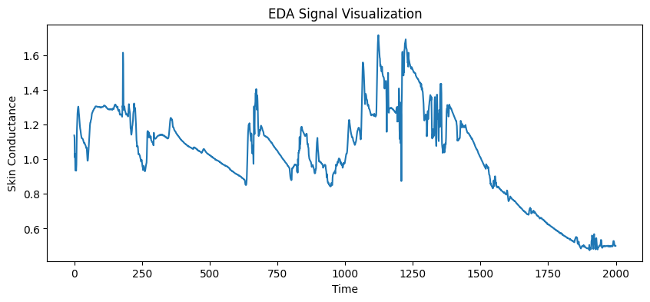
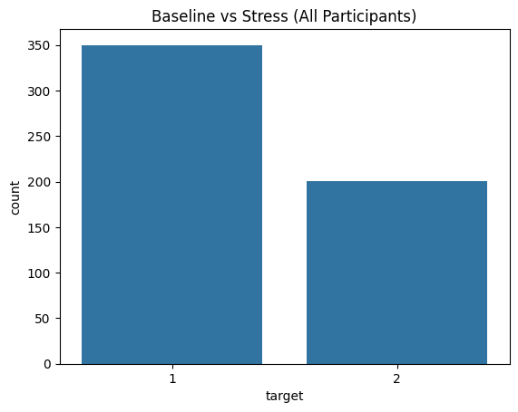

Methodology
The methodology followed in this project includes several steps: data preprocessing, segmentation, feature extraction, model training, and evaluation.
First, the raw signals were loaded and processed. Since the signals are continuous time-series data, they cannot be directly used for training a machine learning model. Therefore, the signals were divided into smaller segments using a window size of 200 samples, which corresponds to approximately 50 seconds. This step helps in analysing the data in smaller and more meaningful sections.
After segmentation, features were extracted from each window. In this project, simple statistical features such as mean and standard deviation were used. These features provide a summary of the signal behaviour within each segment and help convert the time-series data into a structured format suitable for machine learning.
Once the features were extracted, a dataset was created where each row represents a window and contains the extracted features along with the corresponding label.
A Random Forest classifier was then used to train the model. This model is suitable for classification tasks and can handle nonlinear relationships between features. The dataset was split into training and testing sets using an 80–20 ratio. The model was trained on the training data and evaluated on the test data.
The implementation was carried out using Python in Google Colab, with commonly used libraries such as NumPy, Pandas, Matplotlib, Seaborn, and Scikit-learn.

Justification
Random Forest was chosen as the classification model because it performs well on structured data and is relatively easy to implement. It is also less sensitive to noise compared to some other models, which is useful when working with physiological signals that may contain variations.
The choice of simple statistical features such as mean and standard deviation was made to keep the model straightforward and easy to interpret. While more complex features could improve performance, these basic features are sufficient to capture general patterns in the data.
This approach provides a good balance between simplicity and performance, making it suitable for demonstrating the concept of stress detection.

Results
The model achieved an accuracy of approximately 87% on the test dataset. This indicates that the model can distinguish between baseline and stress states with a good level of performance.
The confusion matrix provides more detailed insight into the model’s predictions. It shows that most of the samples were correctly classified. In particular, the model performed well in identifying stress cases, which is important for this application. However, there were some misclassifications where baseline samples were predicted as stress and vice versa.
These misclassifications suggest that some signal patterns are similar between the two classes, making it difficult for the model to clearly separate them in all cases.
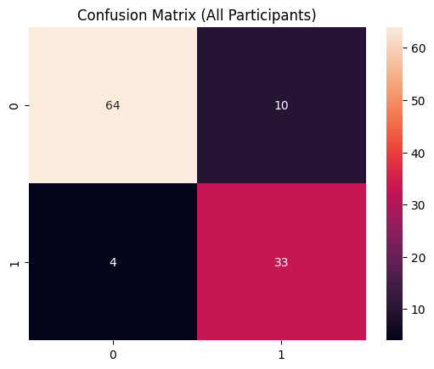

Discussion
The results of this project demonstrate that physiological signals can be effectively used for stress detection using machine learning techniques. The achieved accuracy shows that the extracted features contain useful information that helps the model differentiate between baseline and stress conditions.
However, there are several factors that affect the model’s performance. One of the main reasons for misclassification is the overlap between stress and baseline signals. Physiological responses are not always clearly distinct, and in some cases, the signals may appear similar.
Another important factor is the variation between individuals. Different people may react differently to stress, which makes it difficult for a single model to generalise across all participants. This variability reduces the overall accuracy when more participants are included.
In addition, the use of simple features such as mean and standard deviation limits the model’s ability to capture more detailed patterns in the signals. While these features are useful for basic analysis, more advanced feature extraction techniques could provide better performance.
Despite these limitations, the model still produced reasonable results, showing that even a simple approach can be effective for stress detection.
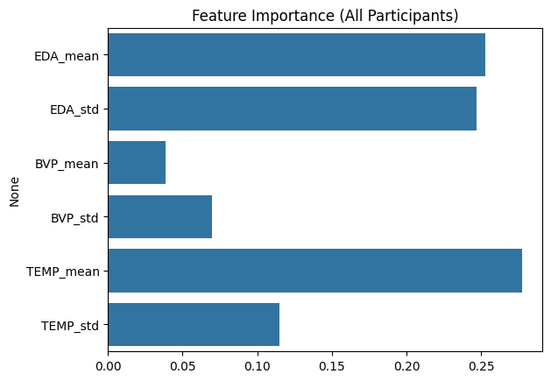
Conclusion
This project concludes that stress detection using wearable physiological signals is possible using machine learning techniques.
The Random Forest model was able to classify stress and baseline states with good accuracy. Since stress is a major factor in relapse, this approach can be useful for early relapse risk detection.

Limitations and Future Work
Limitations
* The dataset does not include actual relapse data, so stress is used as an indirect indicator
* Only basic statistical features were used
* There can be overlap between stress and baseline signals
Future Work
* Use more advanced features from the signals
* Use deep learning models such as CNN or LSTM
* Use large and more relevant datasets
* Develop a real-time monitoring system using wearable devices

